Newsroom Implementation and Custom Features

**Creating News Article Pages:**

Five unique news article pages are created under /content/us/en/news. Each page uses the News Component to display the title, news details, and published date.

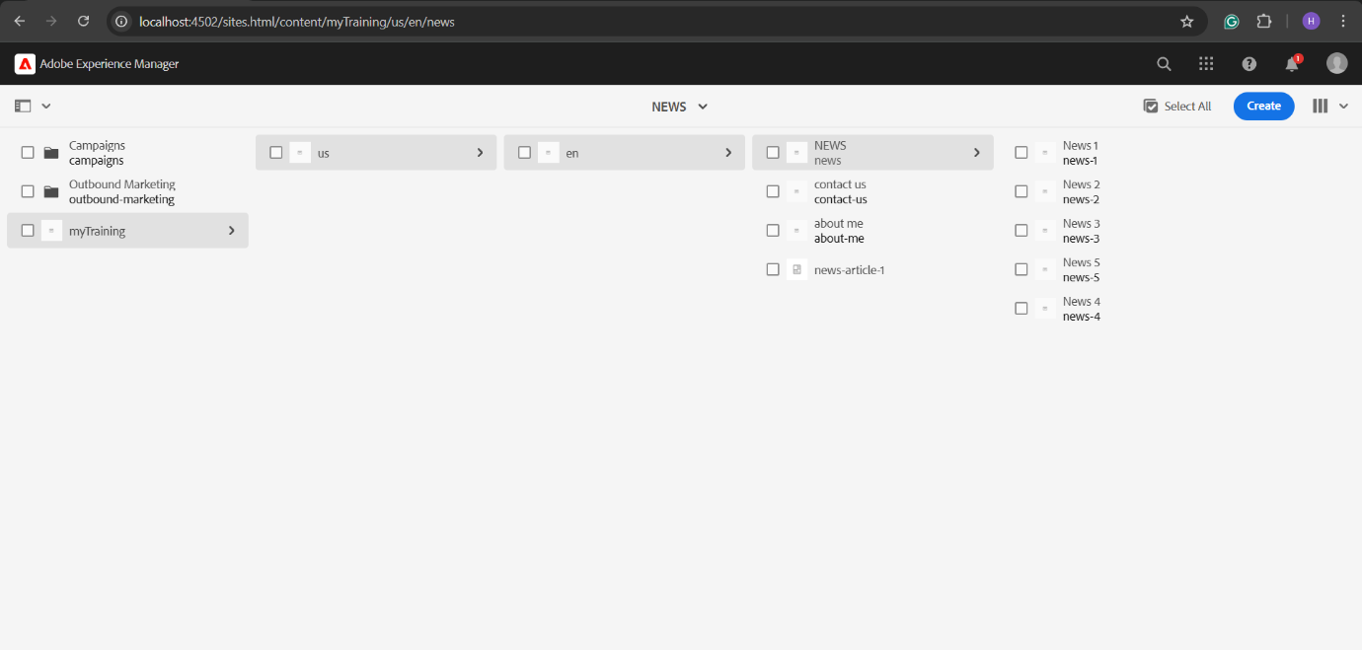

**Create Header Experience fragment for header and use these page as menu:**

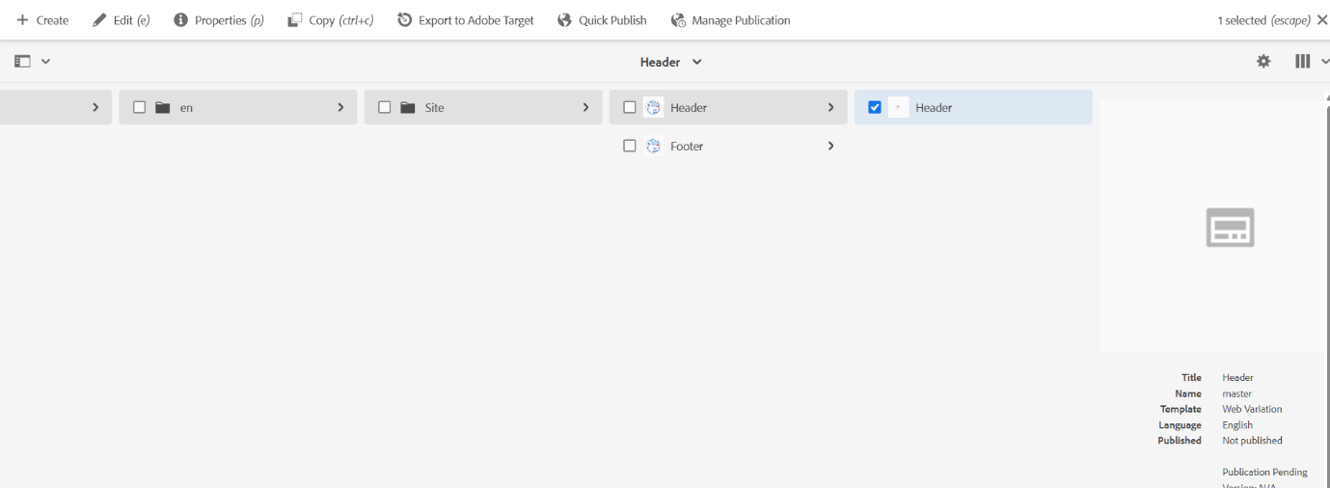

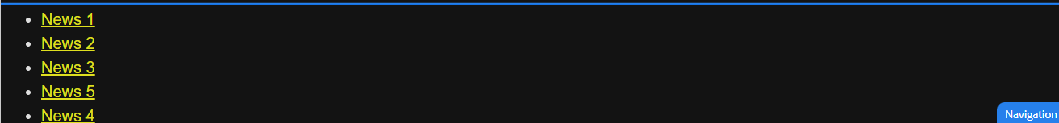

**Create footer XF and it could have 4 sections**

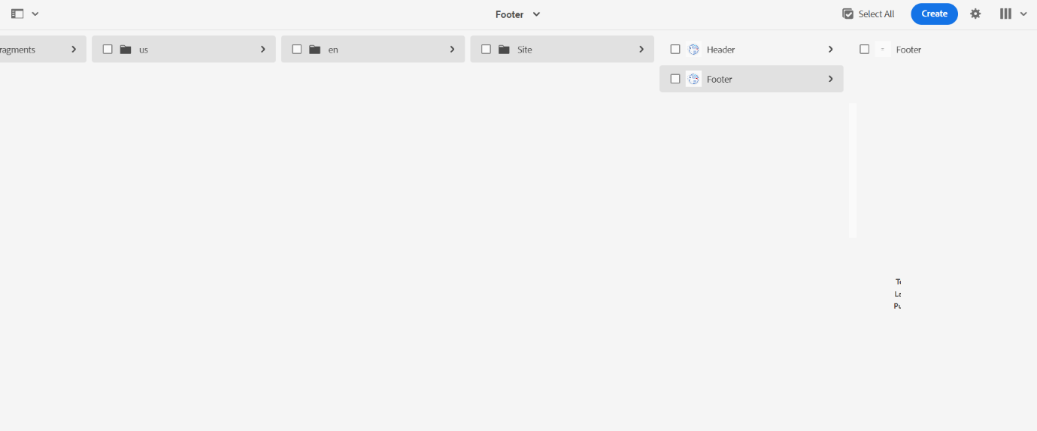

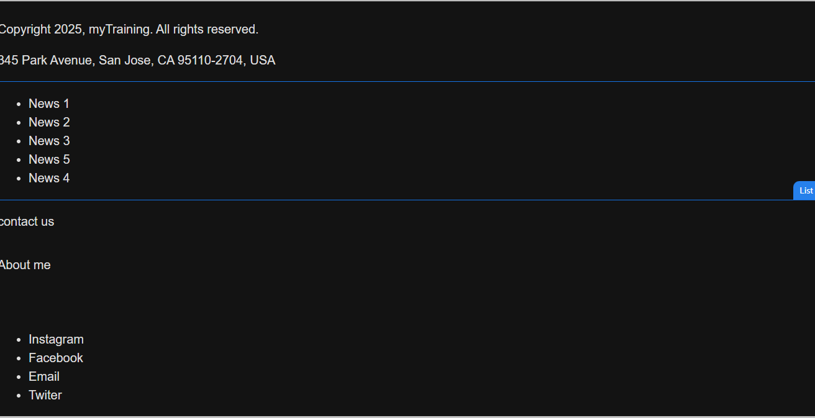

**Create a custom service to print hello world and call this service from news component sling model and print this value in logs as well.**